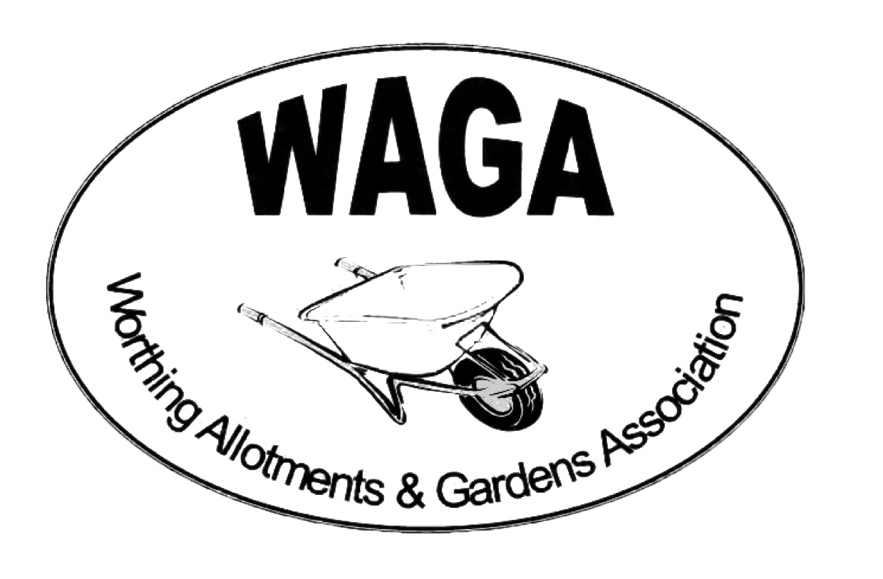

SUMMER 2018
Welcome to your new-look Plotholder Newsletter. The Newsletter will be published four times a year, roughly coinciding with Spring, Summer, Autumn and Winter. News is also regularly updated on the WAGA website: https://waga1.weebly.com
ANNUAL SHOW – from Jack Powis
Our "Great Village Show" is at Oak Grove College again this year on Saturday 1st September. This is later than usual to avoid clashing with the Worthing Horticultural Society's summer show. Everything you need to know is in the show schedule – pick one up from any of our shops – and everyone is welcome to come along and get involved. The show has something for everyone: fruit, vegetables, flowers, flower arranging, cookery, crafts, photography and wine-making. If you are new to gardening – no problem, we have a novice section just for you. We also have a section for children, so do encourage your children and grandchildren to take part.
There will be numerous sales stalls and refreshments including tea and home-made cakes as well as a BBQ. Oak Grove’s award-winning gardens will be open for you to stroll around and the children's play area will keep youngsters amused.
A big event like this relies on many willing hands and although we have a wonderful team, more volunteers to spread the load are always welcome, so if you can help in any way, even for part of the time, please ring Jack Powis on 01903 243216 or email jackpowis@hotmail.co.uk.

GARDENS AND ALLOTMENTS COMPETITIONS – from Jack Powis
Here is an invitation to enter our annual competitions for the Best Front Garden, Best kept Allotment and the Most Improved Allotment (open to tenants in their first full year)
Why not enter and see if you can win one of the cash prizes?
For gardens, the judges consider the condition of plants, colour and harmony, design and layout, lasting potential and weed control.
For allotments, the judges look at quality of crops, weed control, environmental approach and diversity of crops.
Have a go, it will cost you nothing and you might win some cash. The application form is at the end of this newsletter and the closing date is 7th July 2018.

PLASTICS – from Janet Robins
At the moment there is lots in the news about the blight of plastic on our environment and pressure on us all to use it less and recycle wherever possible. Since getting an allotment, I have noticed ways in which people are very creative with unwanted materials and thought it would be interesting to find different ways of using plastic rather than discarding it. At West Tarring allotments we have several examples, some practical and others that are creative. I thought it would be interesting to share these and ask other people to pass on other useful ideas to our members.
- You can line a compost bin with used compost bags. This helps the bin to heat up and create compost quicker.
- You can use plastic bottles as cane toppers.
- You could use milk cartons as an irrigation system in pots, meaning you can leave it longer between visits.
- You could be truly creative and create a sculpture!
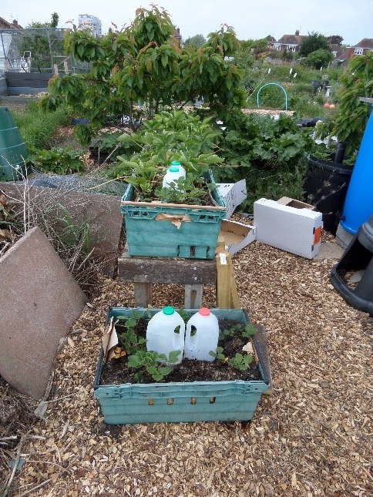
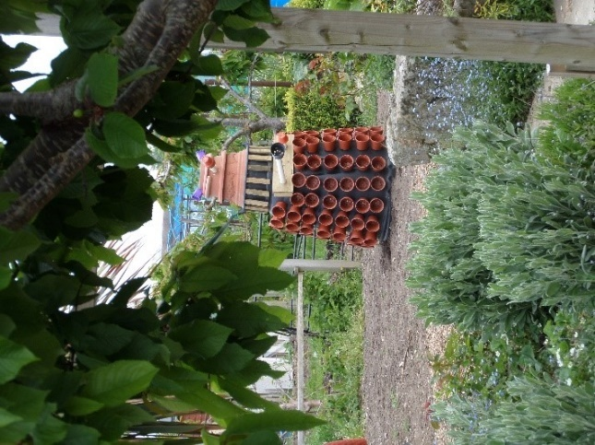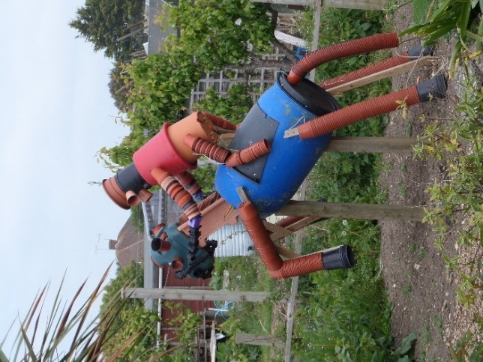

HEDGEHOGS AND SLUG PELLETS – from Janet Robins and Dab Alden
​We all want to protect our plants from a variety of nasty pests and top of the list is always slugs. We all hate them and they can do terrible damage which is very frustrating. What is also awful is the damage we can do to our local wildlife if we use non-organic ways of treating this problem. At Chesswood Farm site we recently found three dead hedgehogs. These may or may not have been poisoned by people using ordinary (non-organic) slug pellets.
If non-organic pellets are used, the ground has dead slugs and lots of slimy mess. These dead slugs are eaten by hungry birds who take them to their nests, or by hedgehogs looking for food.
If you use organic slug pellets, the slugs go underground to die, so no dead bodies and no nasty slime! We sell several organic alternatives to traditional products in all of the WAGA shops:
- Organic slug pellets - £3/£4.60
- Organic weedkiller - £5.50/£15
- Grazers plant invigorator whitefly/slug - £4.30
- SB Invigorator - £3
If you encourage wildlife to come safely to your plot it will help and reward you by eating unwanted bugs and pests week after week.
​
Further information on slug pellets:
Using organic pellets is the best way to avoid the unintentional poisoning of hedgehogs. There are two types of chemical used in blue pellets - Metaldehyde and Methiocarb. The less common methiocarb is about ten times more poisonous than metaldehyde and so poses far greater danger to other animals – please avoid it. Research indicates that hedgehogs are less likely to be harmed by eating slugs that have been poisoned by Methaldehyde (see WAGA website for further info on this research). The problem is more likely to be caused by poor application of the poison by placing it in piles where large quantities can eaten directly or it could become stuck to a food source such as bread or the body of a dead slug.

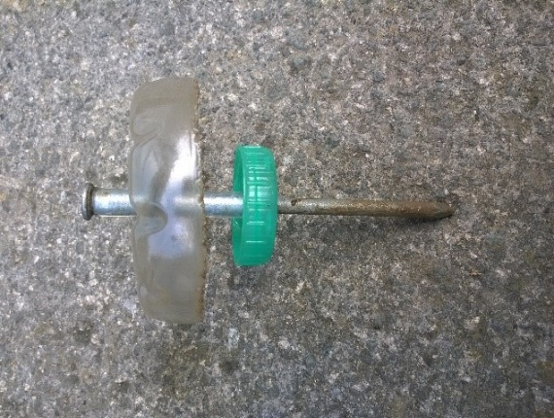
If you’re not ready to give up on slug pellets, here is another way to recycle plastic. Make a slug trap. The top is from a fruit juice bottle. The pellet holder is a milk bottle cap. Both threaded onto a six-inch nail and are separated by some transparent tubing. The top shields the pellets from the rain so no blue liquid forms and the pellets can last for a couple of months. It works very effectively with just four or five pellets and if used in a netted area there is very little chance that poisoned slugs will be eaten by birds or mammals.

VISITS TO ROYAL HORTICULTURAL SOCIETY (RHS) GARDENS
WAGA can offer members a 30% reduction on visits to all four RHS Gardens at Harlow Carr, Hyde Hall, Rosemoor and Wisley with Reduced Price Entry cards.
Each card admits two adults and is valid from March to February every year. WAGA has two of these cards, so if you would like to use them just contact Dab Alden on 07903 867482 or email Secretary@worthingallotments.co.uk.

BBQ TIME!
Two barbeque social events have been arranged as follows:
West Tarring – Friday 20 July, 6.30pm, Plot 90.
Chesswood – Friday 3 August , 6.30pm, Next to store.
Costs are £3.00 per person, please bring your own drinks.
All members welcome.

THANKS go to……
……..Sarah and John Scrace for hosting the tea and cake afternoon in May on Plot 90 at West Tarring. This provided a very welcome break from weeding and a useful boost to WAGA funds.

RECENT COMMITTEE CHANGES
The WAGA Committee would like to thank Paul Eustice and Rik and Lorraine Pease for all their hard work on the committee and in the WAGA shops. They are all still about but focusing on WAM projects. The Committee welcome back Ian Dunster as Acting Chair.
With great sadness, we announce the death of Graham Strong, Treasurer and plot holder at Humber, who passed away in May 2018. Graham was cared for at St Barnabas Hospice and if anyone would like to make a donation in Graham’s memory it would be warmly received.
The revised committee members list can be viewed on the WAGA Website at: https://waga1.weebly.com/committee-members.html
Treasurer – vacant Committee position
Due to the passing of Graham Strong we are looking for a new Treasurer. You don’t need any previous experience as all training is given, but it would help if you enjoy working with numbers. If you have done this sort of job before or if you would like to learn a new skill then please contact Dab Alden at secretary@worthingallotments.co.uk or telephone 07903 867482
- - - - - - - - - - - - - - - - - - - - - - - - - - - - - - - - - - - - - - - - - - - - - - - - - - - - - - - - -

ENTRY FORM – BEST KEPT GARDEN, BEST KEPT ALLOTMENT

Return to Jack Powis, 38 The Boulevard, Worthing BN13 1LB (01903 243216).

****** CLOSING DATE FOR ENTRIES: 1 JULY 2018 ******

Name

Address with postcode

WAGA membership number

I want to enter (please tick) | Best Front Garden Competition  Best Kept Allotment Competition  Most Improved Allotment Competition
My allotment is at (site)
Plot number

Signed _______________________________________ Date __________________________

